Community Foundation News


No. 86 May 16, 2008

Partnership with Aliant

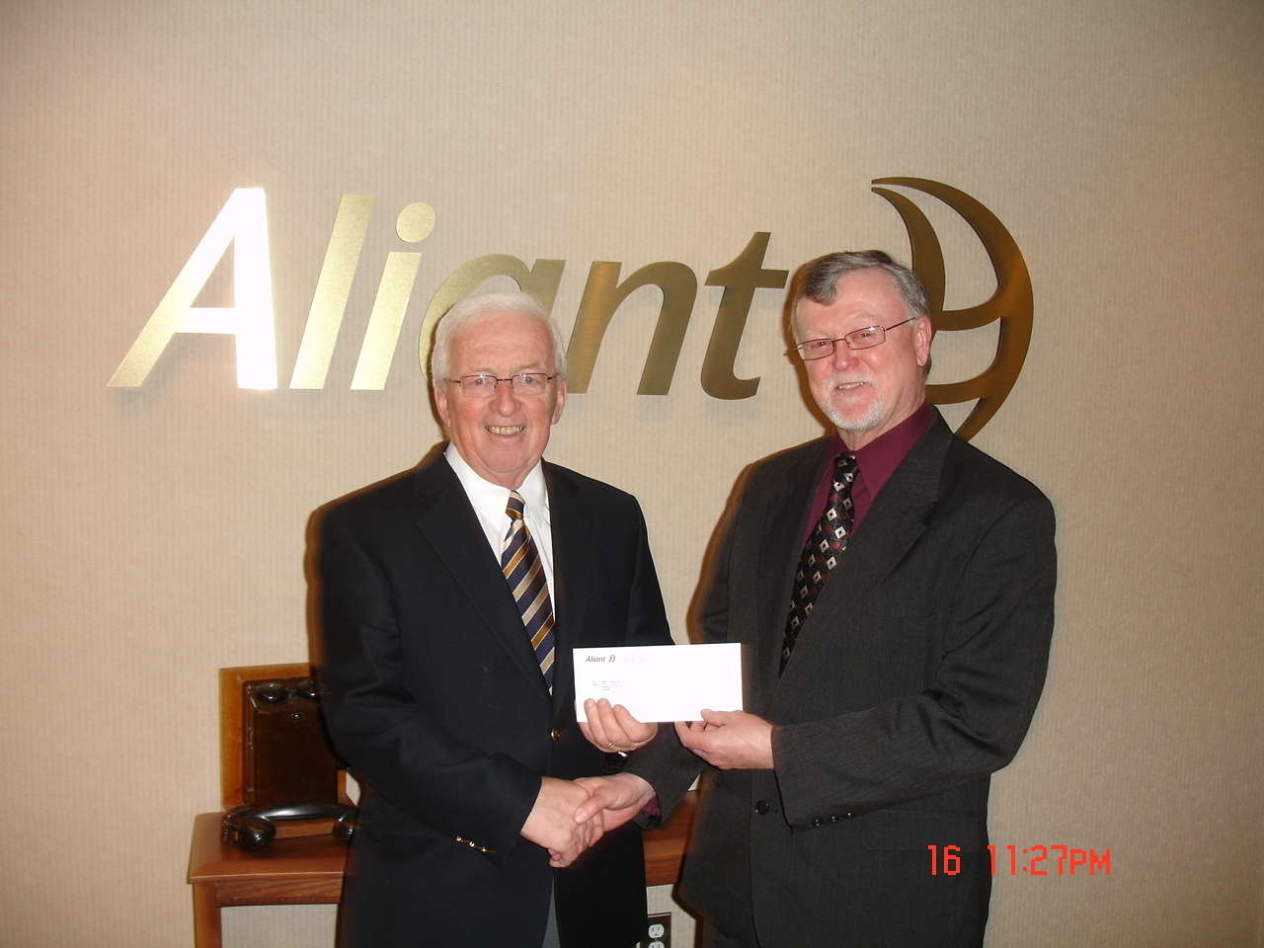Keith Lambe of Aliant presents cheque for $500 to Norman Carruthers, President of the Community Foundation of Prince Edward Island _

CFPEI partners with many organizations and agencies with mutual interests in improving the quality of life of Islanders and Island communities. In so doing, we are pleased to recognize the role of Aliant in providing us with advanced telephone and internet solutions to meet our mission – that of establishing charitable trusts to the benefit of the Community in which we both operate.

___________________________________

Community Foundation
of Prince Edward Island
119-121 Queen Street, Suite 105
Charlottetown, PEI C1A 4B3
Tel: (902) 892-5859
1-800-566-7307
Email: foundation@cfpei.ca
Website: www.cfpei.ca

First Annual Fundraiser

When:
Wednesday, August 20

Where:
Roma at Three Rivers National Historic Site
Brudenell Point (Route 319)
Brudenell. PEI

Menu:
6:00 – 7:00
Reception: Cash Bar
Steamed Mussels with Period Bread

Meal at 7:00
Squash Soup,
Beet and Pearl Onion Salad,
Choice of Roast Loin of Pork or Salmon,
Maple Ginger Turnip, Red Cabbage with Caraway and Blue Cheese and Small Red Potatoes
Dessert – Chef’s Surprise; Tea/Coffee

Entertainment:
Singing Strings
Entertainment and Service
In Period Costume

Ticket Price:
$90.00 per person
(Includes a $50 Charitable Donation Receipt)

Dress:
Smart Casual

Tickets:
Available from
CFPEI – 892-3440
and any Director

